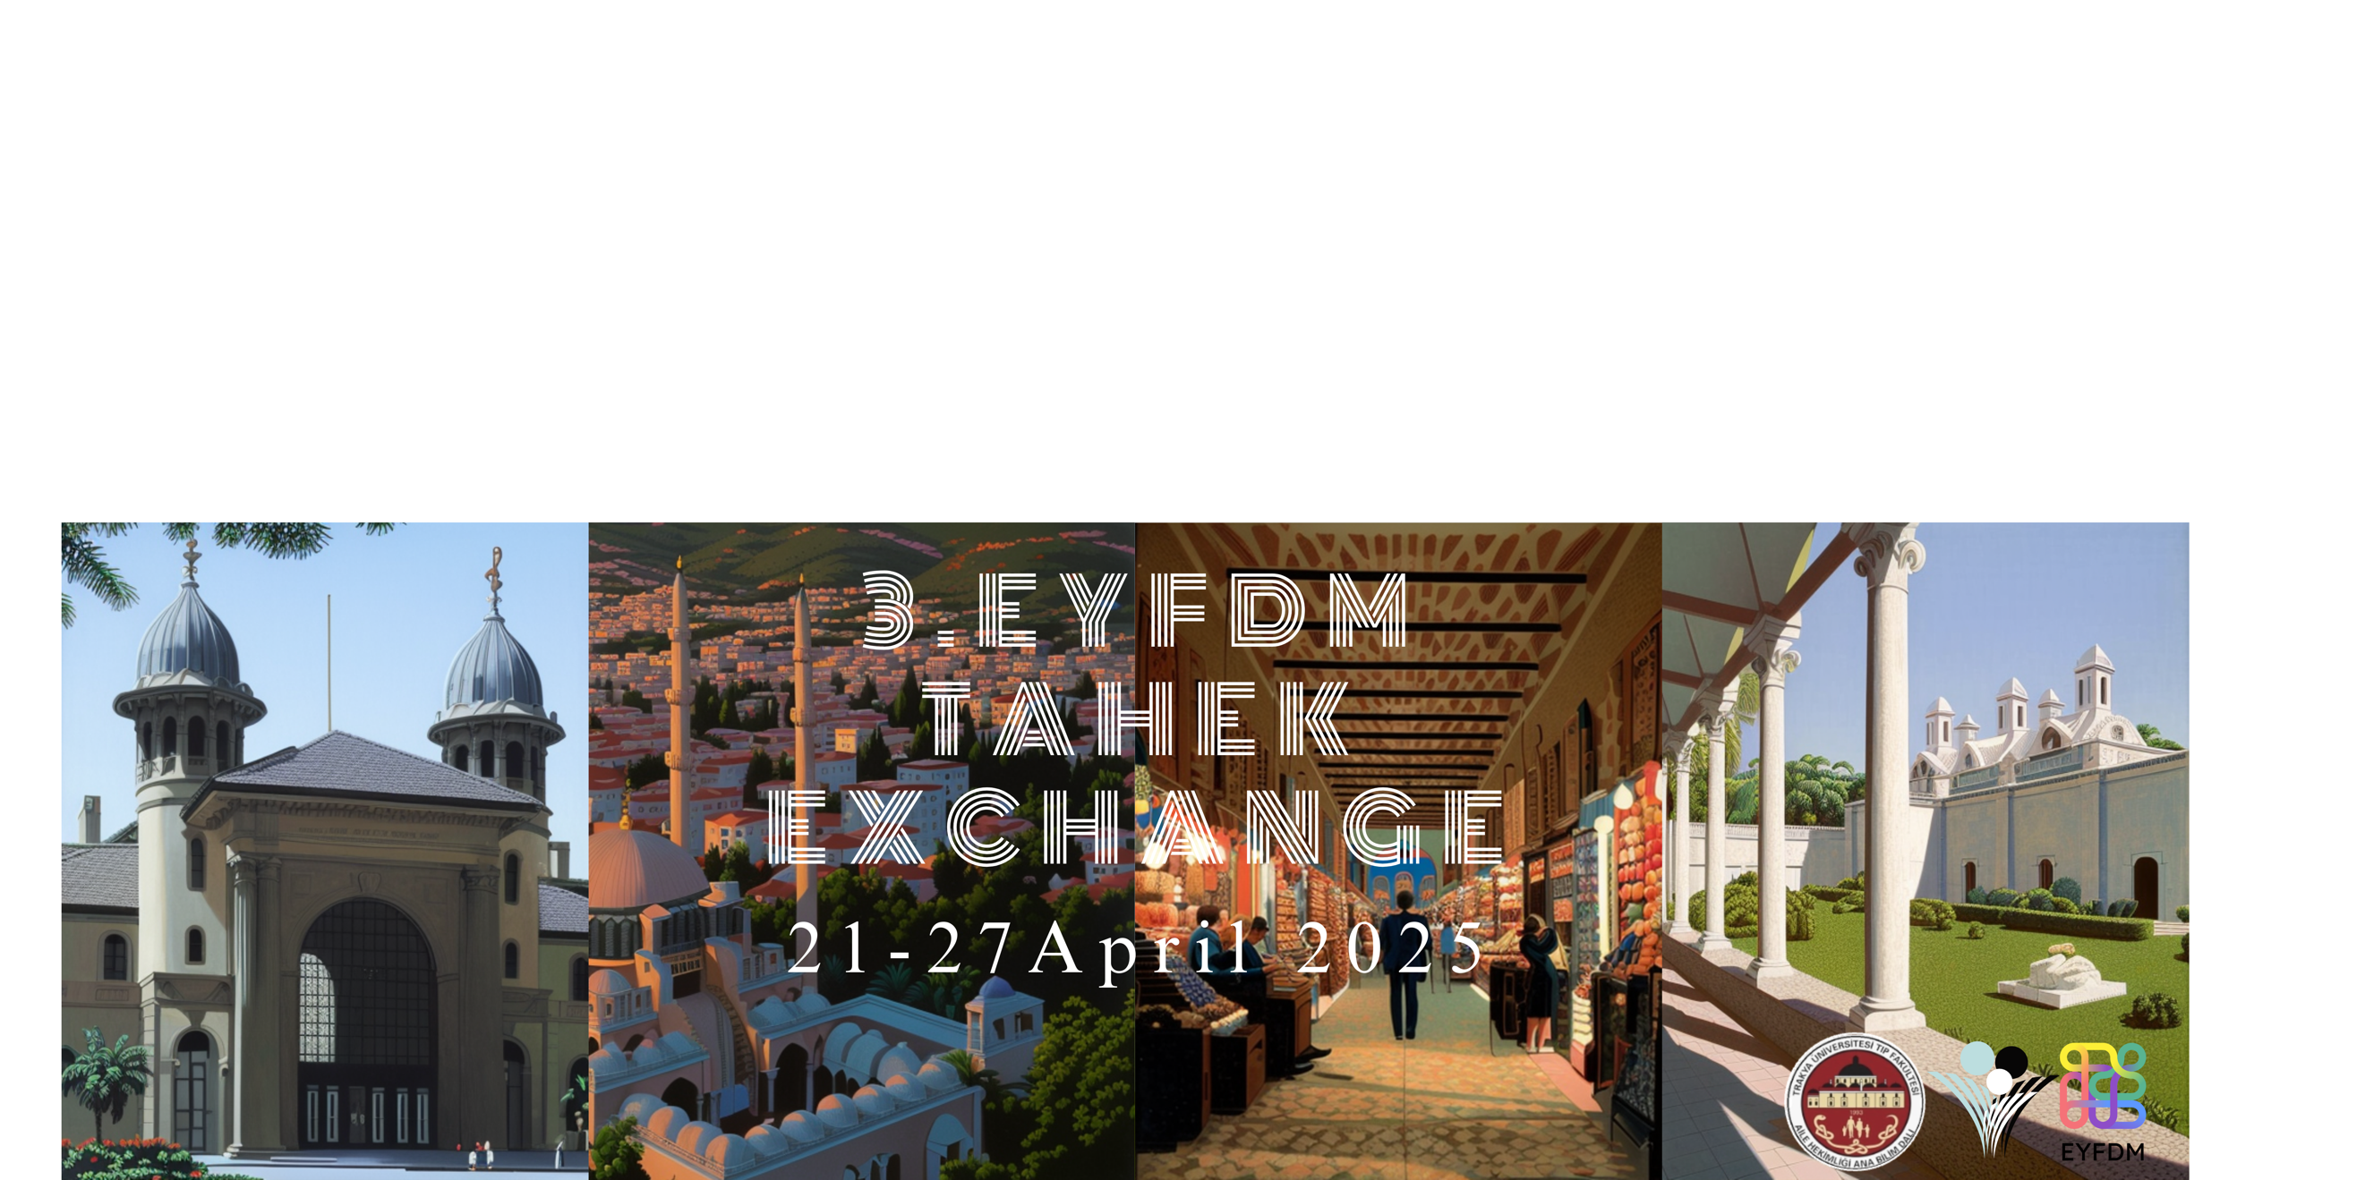

Announcement of Conference Exchange for TAHEK, Edirne, Türkiye!

Dear EYFDM colleagues,

We would like to invite you to participate in the Conference Exchange in Edirne, Türkiye from 21st to 27th of April 2025. 14th International Trakya Family Medicine Congress will hold in Trakya University Balkan Congress Centre from 24th of April to 27th of April with the theme of ‘’Self Care for Health Care’’. This year theme will give us the opportunity to discuss in detail the health of the health professionals especially family physicians, which is one of the most important keys to providing health to the population.

Conference-Exchange Information:

Arrival:
Edirne is the border city between Greece and Bulgaria and has border gates to these two countries via highway connections. We kindly will expect from participants to be in Edirne in 21st of April. Our program will start afternoon (around 2.00 pm UTC+3).

- The most eligible airport is Istanbul International Airport (IST) in Istanbul. Guests can reach to Edirne by several ways. Firstly, you can directly get to the transportation floor which is inside the airport building at -2 floor. Then you can take an inter-city bus ride (ISTANBULSEYAHAT) from platform 18th to Edirne Coach Station. The bus ride would take about two and a half- three hours and ticket prices around 13 euros (price can change depends on demands by the time when you arrived).
For more information: click here

- Another option is you can take a bus ride (HAVAIST) from Istanbul Airport to Halkali Train Station and you can take a train ride from Halkali to Edirne. For more information: click here.

- If you have any plan to travel Istanbul city first and then want to reach Edirne later; you can take inter-city bus ride from Esenler Bus Terminal to Edirne by any private bus company (Nilufer, Metroturizm) that you can choose.

- If you choose Sabiha Gokcen ınternational Airport (SAW), again you can take bus ride (HAVAIST)to Istanbul International Airport. Then you can get to transportation floor -2. You can take inter-city bus ride from platform 18th to Edirne Coach Station.

For more information:
https://www.rome2rio.com/s/Istanbul/Edirne

Our recommended option is choosing the first option for being easily accessible and timesaving option.

Primary Care Exchange:
A full day of observational Primary Care Practise on 22nd of April. The attendants will be divided two groups for visiting the primary care centres.

Conference:
Free registration for the 14th International Trakya Family Medicine Congress (TAHEK), from 24th to 27th of April,2025.

Participants will have the opportunity to take an active role in the scientific program, with the approval of the congress committee, in a way that is relevant to the stated congress theme or to the family medicine system in their country.

Social Program:
- Visiting historical places in Edirne
- Gala Dinner
- 3rd Traditional Bowling Tournament of TAHEK Conference Exchange

*More details will be given soon.

Accommodation: All participants will be accommodated in Family Medicine trainee/ FP’s home for free. We kindly ask you to indicate your accommodation preferences at the time of application. We also kindly ask you to provide personal information such as if you have any special dietary routines or allergies to certain foods/things, or if you tolerate pets in your accommodation.

What is Not Included:
- Travel expenses and VISA
- Social programme
- Gala Dinner
- Personal expenses

There are 7 places available for the exchange!

Selection will be:
- The candidate has a well understanding and speaking of English.
- The candidate would be expected to play an active role in the EYFDM events or active to spread the experiences in self-country.
- We prefer candidates who have not yet joined an exchange before. But it is not mandatory. (Just to be considered in case of more applications than expected numbers)
- The activity of the applicant in the work of EYFDM and the commitment to our movement will be taken into consideration.
* Last 3 mentioned criteria would considered depend on number of applications.

You can send a Motivation Letter and Curriculum Vitae to your National Exchange Coordinator on word file format.

Deadline is 20th of February 2025.

We are eager to see you all in Türkiye for our amazing conference exchange programme!

Kind regards,

Ekin Dikmen, ND of Türkiye
In the name of EYFDM Türkiye

