

49th Annual Meeting Scientific Symposium of the International Clearinghouse for Birth Defects Surveillance and Research (ICBDSR)

**Primary Prevention, Surveillance and Management of Birth Defects**

At the Cavalieri Art Hotel, St Julian’s

<http://www.icbdsr.org/>

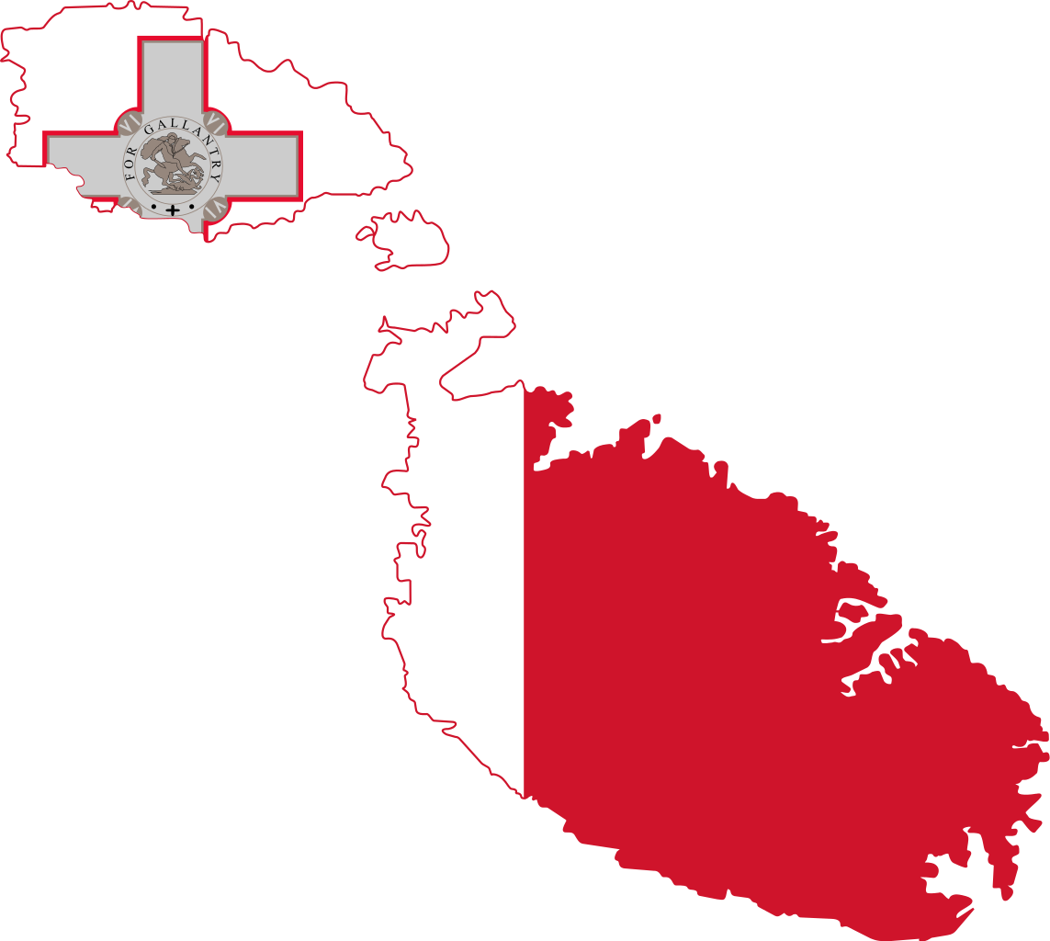

**MALTA**

**6-7th Nove** **mber 2023**



Submit your abstract

Extended Deadline 15 July 2023

